Build your own Online
empire. Let nothing stop you!

X-STARK™

First Step: Steal Free Domains

Obviously the first step requires growing an army of websites.

I’d normally recommend purchasing quality domains and hosting since this will be a long term endeavor. My favorite hosts include Media Temple, Doteasy and Godaddy. Their servers are solidly secure , suffering little downtime. In return, you will spend about $10 a month for each site. Making $1000 to $5000 a month from your
network easily overshadows this cost. All my sites are now hosted on these servers. How about for those on a budget?
No sweat. There are viable solutions for you.

Free Hosting and Subdomains.

If you don’t mind running your sites on subdomains visit these companies:

• Freehostia.com
• X10Hosting.com
• Geocities.com
• AngelFire.com

You’ll obtain sites that follow the following format: yourname.freehostia.com . Not bad since they’re free.

Ad- Free Domains

You can also get ad-free domains at

• www.FreeDomain.co.nr www.Co.cc www.Doteasy.com

And to a certain extent-

Domains afford you that polished look. So, instead of running a site called
mysite.freehostia.com, you can use a domain to redirect to your free host and call it mysite.com

Domain Forwarding

A third option is to obtain free hosting then use a domain forwarding service that redirects to the free hosting for a snappy look. My first choice will be rulestheweb.com
I enjoyed their services years ago since they provided consistent service. You’ll have domains like “travel.to.yourname.com” , “all.at.yourname.com”
and “yourname.rulestheweb.com”

Claiming Your Free MySQL Database

While you can find free hosting solutions at freehostia.com, you also want a MySQL
database. The database is absolutely necessary to run the WordPress software
which will form the backbone of your sites. The free solutions aforementioned don’t offer a mySQL database, so you’ll have to outsource it. You can access free MySQL databases here

www.free-webhosts.com/free-mysql-database.php

After signing up, you’ll obtain databases powered by phpAdmin and DOMXML. Don’t let the jargon chew you up. They work in the background. Once you link the
database to your free host, you can upload your wordpress script to get things flying.

Linking the Domain to the Hosting

Once you obtain your domains (say, at freedomain.co.nr or at rulestheweb.com) you can associate it with the chosen host (say, at freehostia.com) . It simply involves changing the Nameservers.

It’s a one step process. Just register your chosen domain name with your hosting solution!

Let’s assume that you obtained domain www.I-am-rich.co.cc registered at freedomain.co.nr and you have your site hosted at freehostia. Sign up at http://freehostia.com/free_hosting.html . Wait for Freehostia’s login details; these will provide fields for two nameservers. Append the two NameServers to your domain settings at freedomain.co.nr and voila! You have your first online footsoldier
-- a full website with a professional domain name!

Last Resort

You may find the previous techniques quite involved. The alternative is to start off on blogspot blogs (blogger.com) and wordpress blogs (wordpress.com). I don’t
recommend these since you will have minimal control over the site structure and SEO aspect. The redeeming value, however, is that blogger can get you hitting the ground running. Albeit a tad slower

If you Have Money

Got Cash? You can avoid all this shuffling between free host, free SQL and free domain by simply purchasing a domain and hosting in one blow at Godaddy.com or Doteasy.com For $10 a month, you have a complete site that’s irodclad with security, support and consistent operation. The $10 won’t hurt- especially since my target for you is $1000 a month. Minimum.

Second Step : Let’s Build The Army

Deploying The Content

You won’t make money without useful content. That’s why I abhor php scripts that churn out MFA (made for adsense sites). These systems merely regurgitate duplicate content from all over the web and plaster them with Adsense ads. Google likes to sandbox (hide) these low quality sites.

What you will do is different. You will provide a valuable service carrying useful content. I’ve successfully found two tactics that worked fantastically for the past years. These will be your weapons.

Weapon 1: Product Reviews and Scams

I attached a copy of High Paying Keywords with this document (it’s called HPK.pdf). Take note of the words in white highlight in the document. The words “consumer reviews” ,“scam” and “scam reviews” command a lot of clicks. They pay very well.

You see, when folks search the internet for info on new products, they tend to google this way:

“Product X review” “Product Y scam”
“Product Z reviews” “Product M review scam”

The search results then proffer write-ups that make or break the buying procedure. I found this global search habit to be a massive cash cow.
Starting 2004 I launched a series of websites that provide reviews of products on various niches. Some focus on online education, some on gadgets, some on get rich products. The geist is that the sites have the words “ scam ” and “ review ” liberally sprinkled throughout the titles, headings and body text. That means that when
someone looks for “Ipod review” my site will come up. When some one searches for
“rich jerk reviews”, another of m y site appears. I built a cash cow on the search
terms “product X scam” Your sites will likewise benefit because search traffic for the
words “xxx scam” and “yyy reviews” range in the millions! Refer to the HPK.pdf document again.

My first recommendation , therefore, is to launch at least five review sites on niches close to your heart. They can be ebooks, gadgetry, get wealthy systems, cars, online services, forex, or dating.

Once you decide the niches, scour the web for controversial products (people search for these) in each respective niches and create a 100-200 review on the product . It is absolutely VITAL to make sure that the page title and body of the review have the words “review ” and / or “scam” in it.

One of my review sites deal with gadgetry so I often refer to www.ubergizmo.com , www.engadget.com , www.pcworld.com and www.gizmowatch.com . I’d peruse these sites every other day, check out a gadget, and write up my short opinion on
what they already discussed. It helps if I already have a gadget they showcased.

Now, if creating your unique 100-word article turns you off, do what my friend does with his 3-site network that earns $30 a day in Adsense. He simply copies the exact article from another site, and changes words at least 4 times per sentence. He instantly has unique content that bypasses search engine filter s! It works, but I still prefer the unique article method

Monetizing The Reviews

Let’s make money!

You will make money through multiple streams:

• Through Google Adsense (http://www.google.com/adsense)
• Through the Kontera Network ( http://publishers.kontera.com/ )
• Through Cbprosense that earns you clickbank commissions
(http://www.cbprosense.net)
• Through blogvertise.com and reviewme.com (when you get popular.)

Your reviews can be positive or negative. It doesn’t impact your monetization
because they simply create contextual content for the ads that will be surrounding it. Hence it’s a good idea to sign up right now at these ad networks.

When you’re done, flip to the next page.
You will discover my special and highly effective method of creating, monetizing and driving traffic to review sites.

Creating The Review Site

Included with this package is the latest wordpress blogging script. The filename is
wordpress-2.3.3.zip. Expand it and upload it to your server. You will need to propagate its admin panel with the MySQL database details provided by your host.

Once your blog site is running, you have a very plain looking front end. You don’t want that. You want a layout that greatly entices clicks on your ads. I found one such template that maximizes clickthrus. Do install the template called Ads-Minded which is also included with this package. Enter the backend of your Wordpress installation and use the “ Presentations ” menu to activate this theme.

I generate $1,200 to $4,000 a month in adsense alone from 4 review sites. For nearly automatic pilot earnings, this is no figure to sniff at.

Optimizing the Review Sites

Installing Wordpress and the Ads-minded template gets half the battle done. The next half involves uploading the most important wordpress plugins you will ever need to explode your earnings. I appended the package, called Wordpress Plugins Here’s what’s included.

-In-One-SEO-Pack Plugin
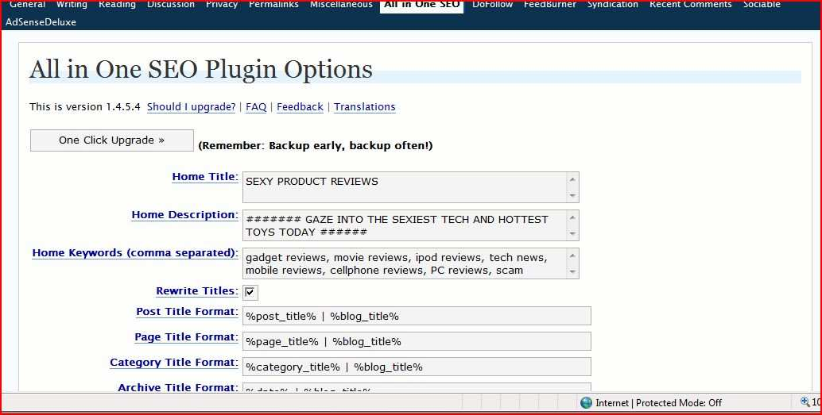

This plugin allows you to accomplish SEO work that is otherwise impossible on a standard Wordpress installation. Once deployed, you will see this control panel added to the Options menu of Wordpress:

Your task is to focus on the Home Title, Home Description, Home Keywords and Metatags fields. They will ultimately compel Google to drive traffic to your niche site- if you put in the right words.

“ Home Title ” controls the <title> tag normally found in html documents. I
recommend you use a short snappy title with the word “Review” or “Scam” in it.
. I’ll let you know why in a second. Keep it ALL CAPS

“ Home Description ” controls the <meta description> tag normally found in html documents. I recommend you write it in the active form and bearing the words
“review” or scam. As before, keep it all CAPS .

Why all caps?

Simple. You want to attract eyeballs to your listing in google. I found that making

this simple change drives a tsunami of traffic to your site. Observe the technique in action. Here’s a standard google listing.
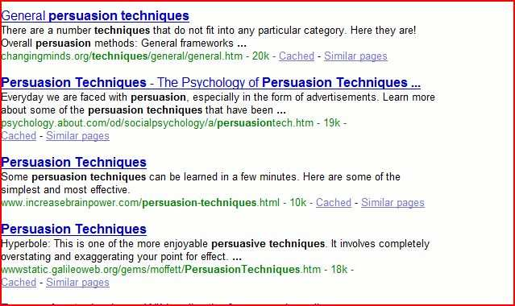

Do any of them attract in you in particular? I bet not. However, by writing your title tags and meta description in all caps, your google listing instantly commands attention . See what one of my sites look like with this change:

The highlighted site receives 15,000 – 20,000 unique visitors a month. I believe one reason is because I employed compelling ALL CAPS title tags. You can embellish your text more with special characters like or >>>>>>>> ######

Done? Proceed now to the Home Keywords and Additional Metatags fields. These fields should contain words related to your niche, as well as the words “review” and “scam”. Filling them this way ensures that when browsers seek information on
products, they find you!

Let’s assume you have a niche on wealth building systems. You will then impregnate both fields with words like “wealth online”, “automatic wealth”, “rich jerk”, “make money fast”, “scam reviews ”, “wealth product reviews”, “rich jerk reviews” Accomplish this step, and every single page on your wordpress site will have these words appearing on the top and the bottom- thereby convincing Google of the relevance of your site to the topic!

I love this tool to hunt for keywords:

https://adwords.google.com/select/KeywordToolExternal

With it you, can discover search terms that hundreds of people use to find certain bits of information. Monetize by focusing on those terms. You’ll get more traffic.

FeedBurner Smith Plugin

There are days when you’ll feel lazy coming up with your unique articles. This can turn off readers who expect fresh content daily. The easiest way to keep serving up the content is to use the FeedBurner Smith Plugin (also included in the

wordpress plugins package I uploaded). Once activated, you can have your
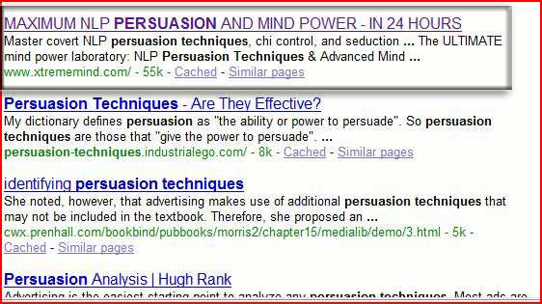

wordpress installation fill your site with articles on a daily basis from external sources. One of my sites- an online education review site- constantly creates

dozens of posts per day using the plugin . There’s a downside, though. It’s all duplicate content. You want to intersperse unique content at least three times a week to please google and rank high. The duplicate content is useful for your readers who probably haven’t seen them elsewhere- and they can click on the ads surrounding them.
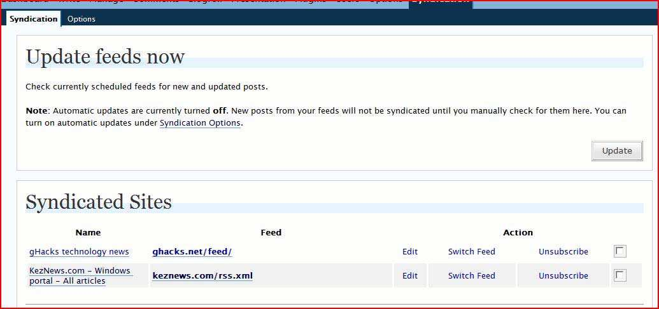

The control panel of Feedburner appears this way:

It’s a straightforward matter of inputting the RSS feed of your favorite, RELATED sites and selecting how often the plugin will create new posts out of these external articles. My tech review site grabs posts from KezNews, Ghacks and more, and leaves appropriate citations. Automatically.

The Optimal Adsense Code

The included Ads-Minded template gives you a site that looks like this:

As you can see, the article is surrounded by ads on all sides. This encourages a very high clickthrough. However, I found an even better way to turbocharge clicking on ads. And that’s by making sure that a 320x300 ad appears embedded in the left hand side of every starting paragraph.

Consider this:

The ads on “Windows Vista” and “Make Windows XP faster” invite eyeballs because it is flush right into the text, not a mere sidebar. You can’t help but see it. When I implemented this, my clicks doubled overnight.

Make the optimization now by going into your Wordpress Backend, clicking the Presentation Menu then selecting Theme Editor . Edit the file called Single Post and look for the line that says <?php the_content('Read the rest of this entry & raquo;'); ?>

You will then insert these lines right before that:

<div style="float:left;margin-top:0px;margin-right:15px;">
Your Adsense Code Here
</div>
<br />

modification instantly creates adsense ads flushed into the first paragraph of
every article. Watch your clickthrus soar! That’s $2000 a month in Adsense for You!

More Monetization!

Remember that I suggested signing up for Kontera Network and Cbprosense.net? These are optional as Adsense alone can net you close to $2000 a month, particularly if your niche deals with technology, money making and software.

However, the additional ad networks can tag on $400 to $2000 extra.

Kontera’s ad code is inserted into the footer.php code of your wordpress template. When active, keywords throughout your site acquire a highlight. When clicked, you make money.

Cbprosense requires that you sign up with Clickbank.com first. After signing up for both, you get customizable code that will display products related to your content. When someone clicks on those links and buys a product, you earn up to 50% commission from clickbank. The Cbprosense program served me well, when integrated next to the comments box of my blog. I chose to display four dynamically related products. Here’s what it looks like. The ads are in red:

Cbprosense doesn’t send the cheques. Clickbank does. The latter mails me amounts up to $800 a month. You can easily achieve the same- particular ly on a software review site.

Keep the Cbprosense code next to your comment box. It gets clicked on very often in my experience.

Weapon 2: Reiki and Healing

That subheading must have surprised you. What does reiki (healing) have to do with making money? Smile. You’ll discover that you can be charitable- and get rich on the side.

Reiki, in a nutshell, is a method of healing. Many do this remotely and results are

verifiable. Reiki entails absorbing life force (chi energy) and infusing it into an ailing body. Mastering the system doesn’t take long. It involves a few breathing, visualization and projection exercises. Google up “Reiki”, “free reiki” and “reiki attunement” and you’ll see a few hundred sites offering free and paid treatments.
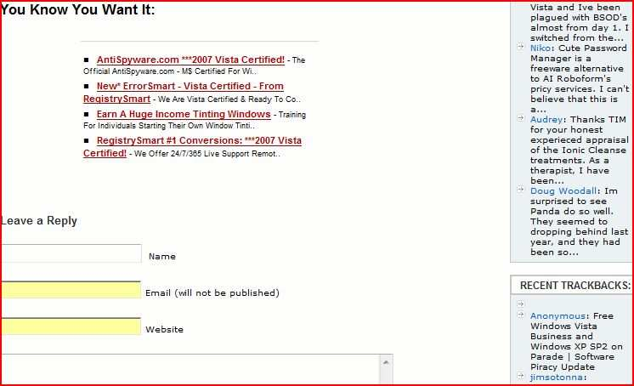

Three years ago, I received a series of reiki treatments that qualified me AS “reiki master”. I paid almost $500 for this. The treatments ultimately gave me the capability to “pass on the gift” to others, thereby enabling them to heal others. Gratitude led me down a probono healing campaign, offering free reiki over the web. Since others charged $100+ per treatment, I attracted a stampede wanting freebies!
Till today, I don’t charge a cent for reiki treatments…. But I discovered an amazing benefit. People who received free treatments ultimately wanted certificates testifying that they obtained as such. I don’t know whether it was for vanity or professional use, but I acceded for free- in the beginning.

Then I found myself running out of sheets and ink. I mailed out free certs almost every day and that cost me. So I began charging for the certificates- $29 to be exact.

Here’s the most recent snapshot of earnings made from the certificates:

That’s $900 at regnow.com- one of my merchant processors. The figure you see comes mostly from certificates; sometimes from allied ebooks. I recently switched to Paypal because I get the income faster.

Be a Reiki Healer!

You can earn while giving free treatments. Google for free reiki attunements. A handful will appear and you can request for distance treatments. It will take about two months for full level of long range healing as well as study of ebooks.

Once you are a certified professional (you’re called a Reiki Master after three attunements), you can setup a site using wordpress scripts advertising your free treatments. Plugin a few ads to make cash on the side.

Avoid what the others are doing; don’t charging for healing. Just charge for the certificates. $15 to $40 is standard and if you get an order a day, you make $1200 a month.

I recommend the following professionals for free training:

http://www.xehupatl.com/

http://www.reikisecrets.com/ http://reiki.7gen.com/join-free-reiki-project.html http://freehealing.org/
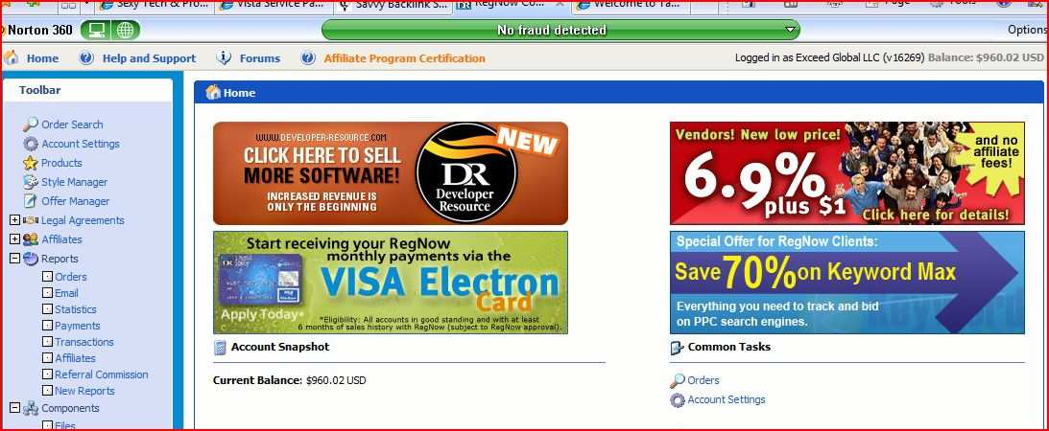

Of course I can recommend myself (I’m listed as #1 in google for free reiki)- but you might feel I’m just after $29. So try the others.

So step by step:
1) Gain at least reiki master level from Xehupatl.com. You’ll need a month.
2) Practice healing your friends to ascertain your capability
3) Set up a simple website detailing your healing services
4) Offer reiki certificates of completion. Charge $29 for certificates.

Google’s Keyword Analysis Tool at https://adwords.google.com/select/KeywordToolExternal indicates extremely heavy demand for reiki attunements and healing. Take your slice of this pie. Today!

Third Step : Capture the Visitors

How to Seize The Traffic

Your sites won’t prosper without traffic. You want real eyeballs and real visitors. Visitors click on your ads and generate you adsense earnings. They also order your certificates!

I’ll enumerate for you some of the most powerful ways I’ve garnered 15,000 unique views per month per website I manage.

Assault Digg
Keep a wary eye on dig.com , newsvine.com, netscape.com and other social news sites. As
stories hit the front page, comment on the article , (no, not on digg).

itself
If something frontpages Digg, you can be sure that it may eventually gain massive
PR from all the traffic going into it. You will benefit from both the PR juice AND the
eyeballs directed to that article from organic traffic and RSS syndication.

Piqq.us for Automated Digging (http://www.piqq.us)

Piqq used to be called diggboss- and it’s a brutal way to obtain a great deal of traffic from Digg.com’s 2,000,000 userbase.

Once you signup (for free), you digg/stumble/propel their members, and in exchange, they extend the same for your stories. It’s vital that your articles possess above average quality- or you can be drummed out of the site. The service may not propel you to the front page, but you can darned expect to reach the ”upcoming”, or “Most Votes So far” page for as long as possible. This will funnel a great deal of traffic your way. You can expect an average of 30 diggs a day for your site by spending a few minutes digging other sites.

Intelligent Trackba cks and Commenting

Fire your browser and check out http://commenthunt.com. The site identifies different blogs implementing a do-follow link policy. Search for friendly blogs and
leave an intelligent comment or two on related topics. Do be aware that blog admins are more vigilant for comment spam in these blogs. Don’t comment on the same blog more than 5x in a single day, or Akismet anti-spam will flush you in the toilet. Also take note of entry dates. Nothing can be more annoying than seeing comments on a 5 year old post.

.Edu Backlinks

I included a program of which I have master resell rights for. It’s called EduBacklinkfinder.jar
. Simply run the script with your keywords and it will return high powered blogs where you can
leave useful comments on. Make sure you
leave a link back to your site for traffic and pagerank juice.

Activating the script lists down the exact urls of locations where you can leave
relevant comments. As URLs age, your comments gain significant PR power and give

you a boost in rankings. Everyone knows that .edu domains receive a great deal of respect from the search engines.

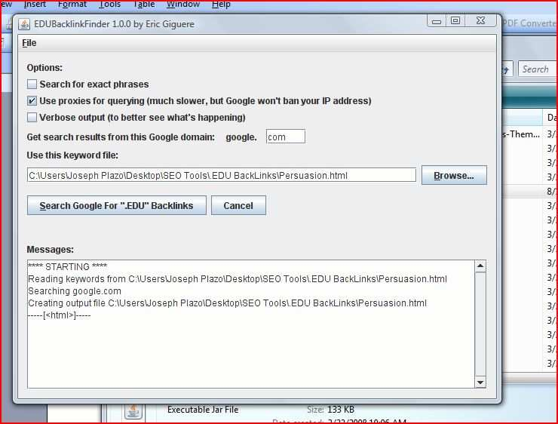

Create a Free Template
Many template sites are more than happy to accept free templates for Wordpress,
Joomla, PhpBB, Drupal and other open source CMS. Either make them yourself, or commission someone to make a pile of beautiful templates for you. The trick is to encrypt a backlink to your site in the footer of these templates so that whenever someone uses them, you get new link love for your homepage. One thing you probably didn’t know is that web design and seo consulting sites got their high pageranks by integrating “powered by xxx” or “designed by xxx” into the footers of their clients’ sites. All those ‘votes’ ultimately earned them stratospheric ranking. Check out statcounter.com, the PR9 site. Their tracking script bears their link on all webs using their services. You can do the same with free templates.
SEOQUAKE Technique
Direct your browser to this page:

http://ff.seoquake.com
You’ll find instructions onsite for it’s installation into the FireFox webrowser.

Now visit google and key in the following search term
“your desired keyword” powered by wordpress “leave a comment”

SEOQuake appends all the search results with amazing detail such as pagerank, Yahoo backlinks and Google indexed pages. You instantly enjoy the power to post comments on sites that that are sure to return heavy visitor traffic and pagerank juice to your review site.

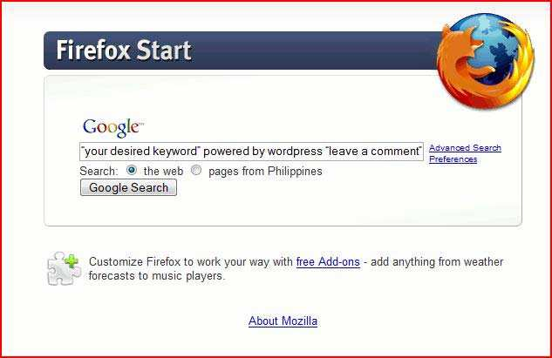

Here’s what SEO Quake does to your browser:

Now you know which sites have high pagerank, a lot of backlinks and a great age! Select those sites with PR2 and above, and leave smart comments in the exact url’s listed. As the backlinks increase, so will your site visitors and rankings in the search engines.

YahooGroups and Google Groups

An oldie but a goodie- being a credible member of both allows you to plug in your

websites by using the signature line in every email. Use sigs that incite curiosity like
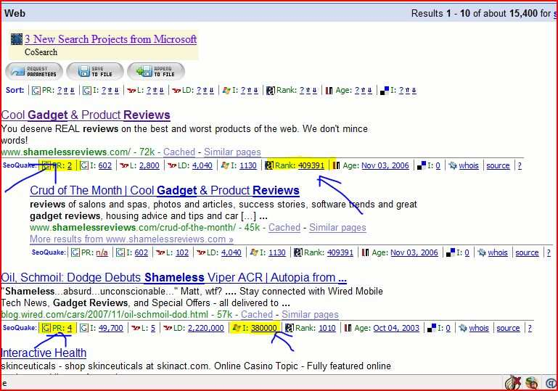

Mark Spencer
Why I Make $10,999 More Than You Do
www.Imakemoremoneythanyou.com
Visit groups.yahoo.com to sign up with pertinent yahoogroups. Remember- contribute valuable comments and promote your site indirectly.

Final Step : Enthrall The Ensnared
Writing Gorgeous Headlines

As a web marker, writing a great headline is a must if you want to capture your reader's interest. Faced with a mounting avalanche of blogs, RSS subscriptions, and ads, the headline is more important now than it ever has been.

So how do you enthrall your readers? How do you get your readers to subscribe? There's no definitive way to maximize your exposure, but there are certainly a few ways that have proven popular. I built up a loyal following with these tactics.

Discuss Keywords & Killer Trends

Folks enjoy reading stories about topics they're passionate about. Many trends endure longer than others, whereas some merely flicker - now if you're writing about a hot topic, remember to drop in those keywords to pique your reader's appetite.

So what defines such a hot topic? Currently 'Vista', or (especially) 'Leopard' in the headline guarantees a good amount of attention. 'QuadCore' and 'Core2Duo' are strong contenders amongst the PC crowd, and fashion like “Prada ” and “Louis Vuitton Knockoffs” also draw huge waves.

For example,

Bad headline : 'TV Program Discusses New FashionProblems'
Good headline : 'Fashion TV Exposes Louis Vuitton Replica Scam'

The word “problems” is too abstract. So is “TV program”. People will say “So What??” But buzz words like Fashion TV and Louis Vuitton Replica Scam appeal to many- you’ll hear many clicks. On your ads!

Super Amazing Tip: Use Superlatives

Okay I used a superlative. But You saw my point. Used on social bookmarking sites, like Digg, you can snag a flurry of clicks on your headline. In fact, it's probably the BEST way.

For example,

Bad headline: 'Good Way to Buy Cheap Bags for your Girlfriend' Good headline: 'The Only Secret Way To Find Branded Bags For Less Than $30'

Not just cheap bags. $30 branded bags. Not just a good way. A way. branded secret
There’s no way to garner boiling interest than to exaggerate and superlativize (is
there such a word). People see them stick out like a sore thumb- and snap them up
like hotcakes. Your mileage may vary, depending on your readership.

So if you must, use the words 'best ever' or 'worst' or 'longest' or 'coolest' in your headline. You’ll burn the servers with clicks.

Keep It Concise

If you aren’t discussing Oprah’s hot miracle cream or a phone that can be labeled as
“ultimate ever”, then your best bet might be to spill the beans in a single sentence.

This sort of headline works dandy for complex reviews - you release the result of
the article in one short sentence … and tantalize the reader's interest enough to click through and devour the whole article.

For example,

Bad headline: 'Company Develops New High Tech Notebook'

Good headline: 'Apple’s MacBookPro Beats 32 Compaq PCs at Chess'

Woah! How about that? Instead of saying it’s fast, you give the reader an image of just how fast it is.

Twist a Question (garbing opinions as a question)

While lawyers are discouraged from leading the witness, the we b marketer makes money posing hidden opinions. They do this by rephrasing a question. It makes great headlines!

Contentious pieces can be crafted as leading questions, preparing the reader for a contrived notion.

For example,

Bad headline: 'QuadCore not much better than the CoreDuo'

Good headline: 'Is the QuadCore any better than the CoreDuo?'

Loaded questions most likely bait fanboys into commenting on your site – as well as linking back to your piece from their own. In fact, one method of generating backlinks fast is to take a polarized stance on a hot topic. Watch people suddenly cut you down to size in their blogs- or praise you as an authority!

Lists Drive People Wild
Can’t think of any other fancy headline. You have a fallback. The List.

Bloggers love list because readers enjoy bitesized iterations. Did you notice how
Cosmo splatters its pages with “Top 5 Ways to Orgasm” or” Six Ways to Lose a Guy”

Lists are great. They’re attractive. They’re compelling. And they make me $2000 a month in adsense.

For example,

Bad headline: 'Great ways to make money this 2009'

Good headline: 'Top Ten Money Making Products for 2009'

Create your list with specifics such as the year '2008' in the example. Specifics add authority and create credibility. Most importantly, people feel they’re up to date.

Thanks …… Keep Going

